Thank you for your interest in purchasing the AEF book!

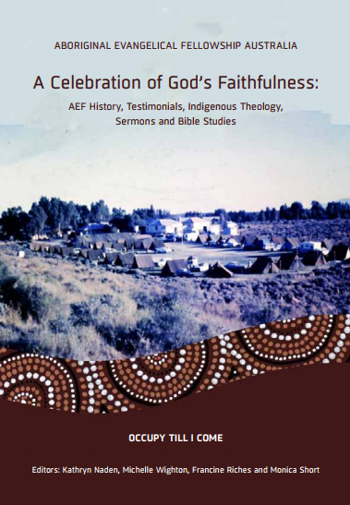
A Celebration of God’s Faithfulness - AEF History, Testimonials, Indigenous Theology, Sermons and Bible Studies by Monica Short and others.
It promises to be a great read and an opportunity to be drawn into the work, life and people of the AEF in Australia.
$22 each. Plus Postage and handling $7.50 for any number of books purchased.
Direct deposit: Aboriginal Evangelical Fellowship BSB 082-810 Acc. 18-449-5529 In the Description put your name and we will know it’s from you. Please let us know if you need a receipt.
Cheque or Money Order: Post to AEF National Office – PO Box 221 Highpoint City Vic 3032

-------------------------------------------------------------------------
----- ORDER FORM -----

POST: AEF National Office – PO Box 221 Highpoint City Vic 3032 OR EMAIL the info. aef@aef.org.au

Please send me …………. Copies of the AEF BOOK - A Celebration of God’s Faithfulness.
NAME:…………………………………………………………………………………………………………………………………………………
ADDRESS:…….……………………………………………………………………………………………………………………………………………………………………………………………………………………………………………………………………………………………………
EMAIL:…………………………………………………………………………………………………………………………………………………
PHONE NUMBER:…………………………………………………..
I have attached/deposited $........... to cover the cost of book/s and postage (if posted).
If you are not yet a member and would like to be please write to us and we will help you with information about it.

Many thanks for your interest and support for the work of the AEF in Australia.

